## EXPERIMENT 10

**AIM:** Write a program to check whether the number entered by user is odd or even.

**ALGORITHM**:

MAINPROGRAM

1. Input number in the memory.
2. Move the number into Alu
3. And the alu with 000H
4. Compare the Data in Alu With 0000H
5. Jump if Compare flag is set , to Even Part to print even in the Destination Index
6. Else Jump to Odd part to Print Odd in the Destination index.

Program: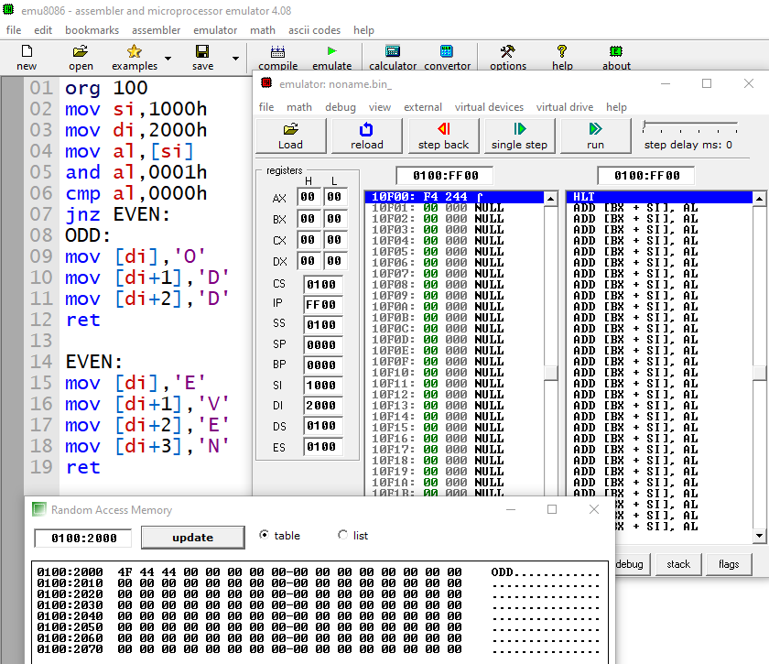

Execution:

**CONCLUSION**: Hence, we executed an ALP to check whether the Input number is Odd or Even.

Name :Abdullah Khan

Roll No: 122A1002 --(02)

Batch :C1 Batch